**I.P. CONVENT SR.SEC. SCHOOL**

Computer AssemBling

(Project in JAVA

& MYSQL)

A report

Towards fulfillment of course in

XII

Informatics

Practices(065)

Submitted BY:

Name: Rishab gupta

Roll No. :9152902

Certificate

This is to certify that the original and genuine work has been carried out

to implement about the subject matter by Rishab gupta of class XII.

She has successfully completed his project on the topic

**“Computer assembling”** under the guidance of her Subject Mentor Miss Ramneet Kaur.

This project is absolutely genuine and does not indulge in plagiarism

of any kind.

Signature

(Subject Teacher)

Acknowledgement

It is with great pleasure to express my sincere gratitude to all those who

have helped me to put my ideas in a practical working platform. I would

like to thank my Subject Teacher Miss Ramneet Kaur for her support,

guidance and encouragement.

I would like to thank my partners Vishal dabas and Shivam yadav of

my Class XII for their support and cooperation.

I would like to thank my school and my parents for providing me a

proper environment and facilities which help me in fulfillment of my

project.

Rishab gupta

XII

index

|  |  |  |
| --- | --- | --- |
| s.no. | contents | Pg.no. |
| 1 | Certificate | 2 |
| 2 | Acknowledgement | 3 |
| 3 | Introduction | 5-7 |
| 4 | Software & Hardware Requirement | 8 |
| 5 | Front End Design | 9-16 |
| 6 | Source Code & outputs respective | 17-29 |
| 7 | Database Design | 30-31 |
| 8 | Program Output | 32-41 |

Overview of java and mysql

**JAVA**

Java is a general-purpose computer programming language that is concurrent, class-based, object-oriented, and specifically designed to have as few implementation dependencies as possible. It is intended to let application developers ”write once, run anywhere” (WORA), meaning that compiled Java code can run on all platforms that support Java without the need for recompilation. Java without the need for recompilation. Java applications are typically compiled to byte code that can run on any Java virtual machine(JVM) regardless of computer architecture.

**MYSQL**

MYSQL is an open-source relational database management system(RDBMS). It was the world’s second most widely used RDBMS, and the most widely used open-source client-servermodel RDBMS. It is named after co-founder Michael Widenius’s daughter,My. The SQL acronymstands for Structured Query Language. The MySql development project has made irs source code available under the terms of the GNU General Public License, as well as under a variety of proprietary agreements. MySql was owned and sponsored by a single for-profit firm, the Swedish company MySql AB, now owned by Oracle Corporation.

Abstract

**“NET LABS”** is a project based on-

FRONT END- JAVA GUI

BACK END-MYSQL

The Internet has now becoming the need for each and every individual

person. Keeping in mind this concept, the project Tour & Travels is

developed to provide ease for the travelers as they can easily choose the place

for their tour and get the tickets. Now, they do not need to consult with

offline depots and to deal with lots of records. It overcomes all these

shortcomings of traditional methods.

Introduction to Computer assembling

**Computer assembling** is an attempt to provide online shopping services to the users.

It provides various activities:

* Start up Page
* Selecting your choice
* Ordering your selection
* Various payment options

Software and hardware requirement

**Software Requirement**

* Front end: Netbeans IDE-7.3.1, Netbeans IDE-8.0.2
* Backend: MySQL Server 5.0
* Operating System: Windows 7, Windows 8

**Hardware Requirement**

* RAM: 2 GB to 16 GB
* Hard Disk: 320 GB to 500 GB
* Processor: Intel Core i3

**Page 1**

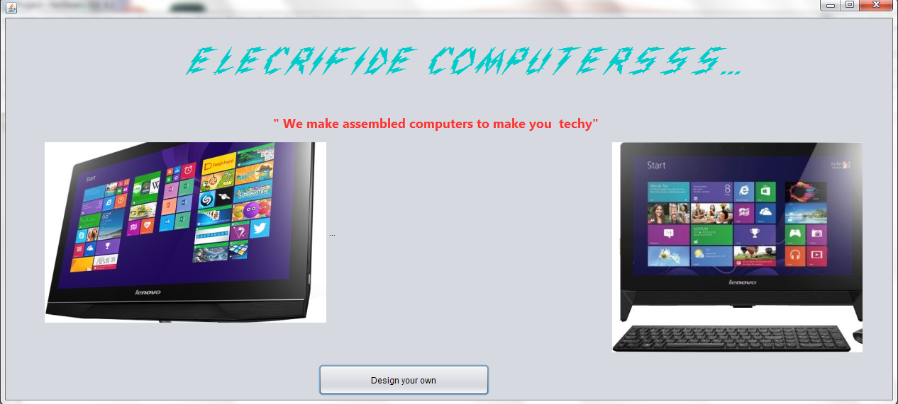

**//Next page**

new second().setVisible(true);

**Page 2**

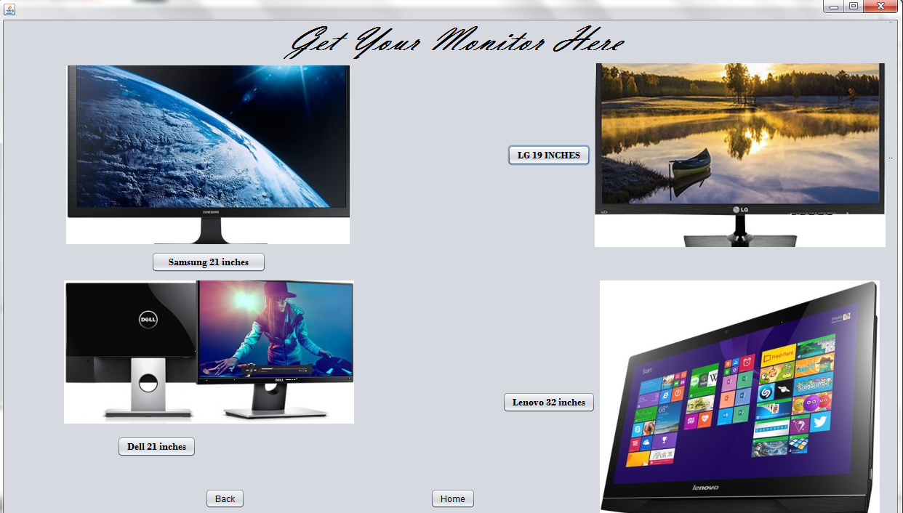

**//To import**

import java.sql.*;

public class second extends javax.swing.JFrame {

private static final String Username="root";

private static final String Password="";

private static final String connstring="Jdbc:mysql://localhost:3306/connection";

**//Back**

new first().setVisible(true);

**//home**

Connection conn;

try{

conn=DriverManager.getConnection(connstring,Username,Password);

Statement stmt=(Statement)conn.createStatement();

String sql="Delete from project;";

int rs=stmt.executeUpdate(sql);

}

catch (SQLException e) {

System.out.print(e);

}

new first().setVisible(true);

**//samsung**

Connection conn;

try{

conn=DriverManager.getConnection(connstring,Username,Password);

Statement stmt=(Statement)conn.createStatement();

String sql="insert into project values('Samsung_21_inches',22000);";

int rs=stmt.executeUpdate(sql);

}

catch (SQLException e) {

System.out.print(e);

}

{

new third().setVisible(true);

}

**//Lg**

Connection conn;

try{

conn=DriverManager.getConnection(connstring,Username,Password);

Statement stmt=(Statement)conn.createStatement();

String sql;

sql="insert into project values('LG_19_inches',12000);";

int rs=stmt.executeUpdate(sql);

}

catch (SQLException e) {

System.out.print(e);

}

{ new third().setVisible(true);}

**//dell**

Connection conn;

try{

conn=DriverManager.getConnection(connstring,Username,Password);

Statement stmt=(Statement)conn.createStatement();

String sql="insert into project values('Dell_21_inches',23000);";

int rs=stmt.executeUpdate(sql);

}

catch (SQLException e) {

System.out.print(e);

}

{ new third().setVisible(true);}

**//Lenovo**

Connection conn;

try{

conn=DriverManager.getConnection(connstring,Username,Password);

Statement stmt=(Statement)conn.createStatement();

String sql="insert into project values('Lenovo_32_inches',50000);";

int rs=stmt.executeUpdate(sql);

}

catch (SQLException e) {

System.out.print(e);

}

{ new third().setVisible(true);}

**Page 3**

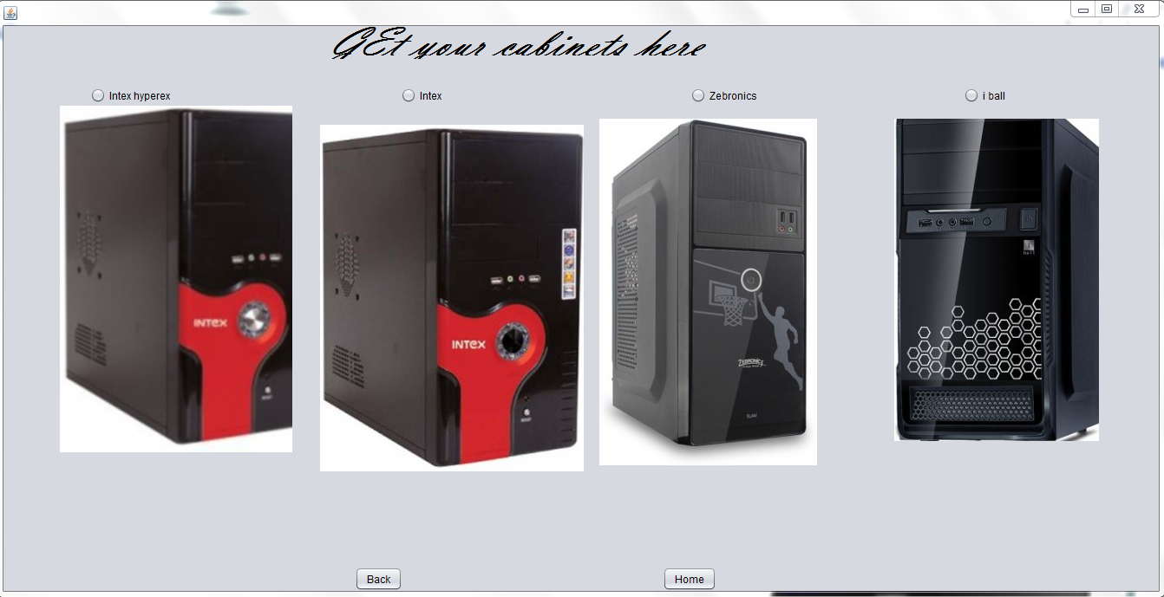

**//import**

import java.sql.*;

public class third extends javax.swing.JFrame {

private static final String Username="root";

private static final String Password="";

private static final String connstring="Jdbc:mysql://localhost:3306/connection";

**//back**

new second().setVisible(true);

**//intex hyperex**

Connection conn;

try{

conn=DriverManager.getConnection(connstring,Username,Password);

Statement stmt=(Statement)conn.createStatement();

String sql="insert into project values('Intex_hyperex',2000);";

int rs=stmt.executeUpdate(sql);

}

catch (SQLException e) {

System.out.print(e);

}

new Fourth().setVisible(true);

**//intex**

Connection conn;

try{

conn=DriverManager.getConnection(connstring,Username,Password);

Statement stmt=(Statement)conn.createStatement();

String sql="insert into project values('Intex',1500);";

int rs=stmt.executeUpdate(sql);

}

catch (SQLException e) {

System.out.print(e);

}

new Fourth().setVisible(true);

**//zebronics**

Connection conn;

try{

conn=DriverManager.getConnection(connstring,Username,Password);

Statement stmt=(Statement)conn.createStatement();

String sql="insert into project values('Zebronics',3000);";

int rs=stmt.executeUpdate(sql);

}

catch (SQLException e) {

System.out.print(e);

}

new Fourth().setVisible(true);

**//Iball**

Connection conn;

try{

conn=DriverManager.getConnection(connstring,Username,Password);

Statement stmt=(Statement)conn.createStatement();

String sql="insert into project values('Iball',3500);";

int rs=stmt.executeUpdate(sql);

}

catch (SQLException e) {

System.out.print(e);

}

new Fourth().setVisible(true);

**//home**

Connection conn;

try{

conn=DriverManager.getConnection(connstring,Username,Password);

Statement stmt=(Statement)conn.createStatement();

String sql="Delete from project;";

int rs=stmt.executeUpdate(sql);

}

catch (SQLException e) {

System.out.print(e);

}

new first().setVisible(true);

new first().setVisible(true);

**Page 4**

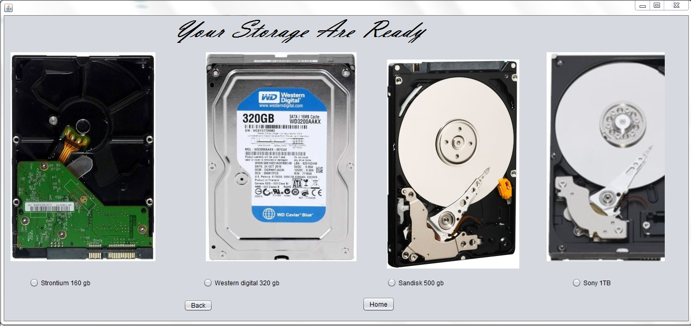

**//import**

import java.sql.*;

public class Fourth extends javax.swing.JFrame {

private static final String Username="root";

private static final String Password="";

private static final String connstring="Jdbc:mysql://localhost:3306/connection";

**//back**

new third().setVisible(true);

**//sandisk 500gb**

Connection conn;

try{

conn=DriverManager.getConnection(connstring,Username,Password);

Statement stmt=(Statement)conn.createStatement();

String sql="insert into project values('Sandisk_500gb',3000);";

int rs=stmt.executeUpdate(sql);

}

catch (SQLException e) {

System.out.print(e);

}

new fifth().setVisible(true);

**//strontium 160gb**

Connection conn;

try{

conn=DriverManager.getConnection(connstring,Username,Password);

Statement stmt=(Statement)conn.createStatement();

String sql="insert into project values('Strontium_160gb',1200);";

int rs=stmt.executeUpdate(sql);

}

catch (SQLException e) {

System.out.print(e);

}

new fifth().setVisible(true);

**//western digital 320**

Connection conn;

try{

conn=DriverManager.getConnection(connstring,Username,Password);

Statement stmt=(Statement)conn.createStatement();

String sql="insert into project values('Western_digital_320',2000);";

int rs=stmt.executeUpdate(sql);

}

catch (SQLException e) {

System.out.print(e);

}

new fifth().setVisible(true);

**//sony 1tb**

Connection conn;

try{

conn=DriverManager.getConnection(connstring,Username,Password);

Statement stmt=(Statement)conn.createStatement();

String sql="insert into project values('Sony_1tb',3500);";

int rs=stmt.executeUpdate(sql);

}

catch (SQLException e) {

System.out.print(e);

}

new fifth().setVisible(true);

**//home**

Connection conn;

try{

conn=DriverManager.getConnection(connstring,Username,Password);

Statement stmt=(Statement)conn.createStatement();

String sql="Delete from project;";

int rs=stmt.executeUpdate(sql);

}

catch (SQLException e) {

System.out.print(e);

}

new first().setVisible(true);

new first().setVisible(true);

**Page 5**

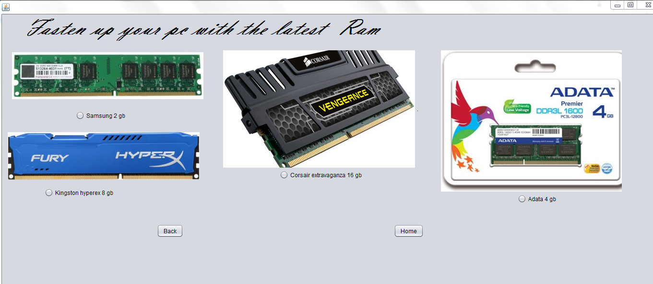

**//import**

import java.sql.*;

public class fifth extends javax.swing.JFrame {

private static final String Username="root";

private static final String Password="";

private static final String connstring="Jdbc:mysql://localhost:3306/connection";

**//back**

new Fourth().setVisible(true);

**//Samsung 2gb**

Connection conn;

try{

conn=DriverManager.getConnection(connstring,Username,Password);

Statement stmt=(Statement)conn.createStatement();

String sql="insert into project values('Samsung_2gb',1000);";

int rs=stmt.executeUpdate(sql);

}

catch (SQLException e) {

System.out.print(e);

}

new sixth().setVisible(true);

**//adata 4gb**

Connection conn;

try{

conn=DriverManager.getConnection(connstring,Username,Password);

Statement stmt=(Statement)conn.createStatement();

String sql="insert into project values('Adata_4gb',1500);";

int rs=stmt.executeUpdate(sql);

}

catch (SQLException e) {

System.out.print(e);

}

new sixth().setVisible(true);

**//Kingston 8gb**

Connection conn;

try{

conn=DriverManager.getConnection(connstring,Username,Password);

Statement stmt=(Statement)conn.createStatement();

String sql="insert into project values('Kingston_hyperex_8gb',3000);";

int rs=stmt.executeUpdate(sql);

}

catch (SQLException e) {

System.out.print(e);

}

new sixth().setVisible(true);

**//Corsair**

Connection conn;

try{

conn=DriverManager.getConnection(connstring,Username,Password);

Statement stmt=(Statement)conn.createStatement();

String sql="insert into project values('Corsair_extravaganza',5000);";

int rs=stmt.executeUpdate(sql);

}

catch (SQLException e) {

System.out.print(e);

}

new sixth().setVisible(true);

**//home**

Connection conn;

try{

conn=DriverManager.getConnection(connstring,Username,Password);

Statement stmt=(Statement)conn.createStatement();

String sql="Delete from project;";

int rs=stmt.executeUpdate(sql);

}

catch (SQLException e) {

System.out.print(e);

}

new first().setVisible(true);

**Page 6**

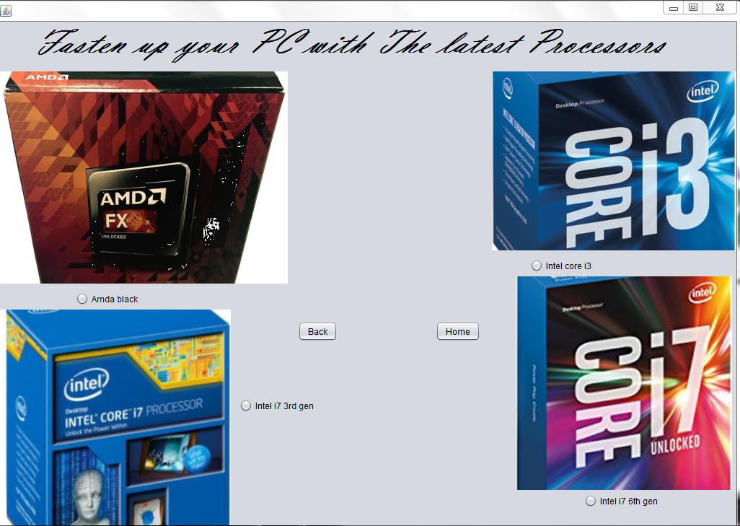

**//import**

import java.sql.*;

public class fifth extends javax.swing.JFrame {

private static final String Username="root";

private static final String Password="";

private static final String connstring="Jdbc:mysql://localhost:3306/connection";

**//back**

new fifth().setVisible(true);

**//Amda black**

Connection conn;

try{

conn=DriverManager.getConnection(connstring,Username,Password);

Statement stmt=(Statement)conn.createStatement();

String sql="insert into project values('Amda_black',15000);";

int rs=stmt.executeUpdate(sql);

}

catch (SQLException e) {

System.out.print(e);

}

new seventh().setVisible(true);

**//Intel i3**

Connection conn;

try{

conn=DriverManager.getConnection(connstring,Username,Password);

Statement stmt=(Statement)conn.createStatement();

String sql="insert into project values('Intel_corei3',19999);";

int rs=stmt.executeUpdate(sql);

}

catch (SQLException e) {

System.out.print(e);

}

new seventh().setVisible(true);

**//intel i7 3rd gen**

Connection conn;

try{

conn=DriverManager.getConnection(connstring,Username,Password);

Statement stmt=(Statement)conn.createStatement();

String sql="insert into project values('Intel_i7thirdgeneration',35000);";

int rs=stmt.executeUpdate(sql);

}

catch (SQLException e) {

System.out.print(e);

}

new seventh().setVisible(true);

**//intel i7 6th gen**

Connection conn;

try{

conn=DriverManager.getConnection(connstring,Username,Password);

Statement stmt=(Statement)conn.createStatement();

String sql="insert into project values('Intel_i7_6thgeneration',37000);";

int rs=stmt.executeUpdate(sql);

}

catch (SQLException e) {

System.out.print(e);

}

new seventh().setVisible(true);

**//home**

Connection conn;

try{

conn=DriverManager.getConnection(connstring,Username,Password);

Statement stmt=(Statement)conn.createStatement();

String sql="Delete from project;";

int rs=stmt.executeUpdate(sql);

}

catch (SQLException e) {

System.out.print(e);

}

new first().setVisible(true);

new first().setVisible(true);

**Page 7**

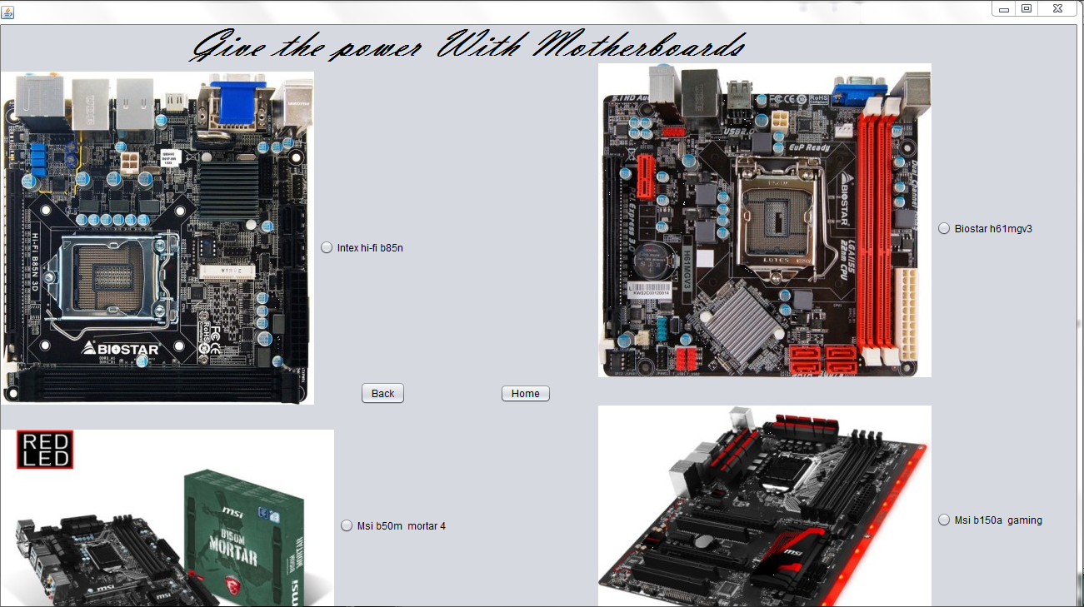

**//import**

import java.sql.*;

public class fifth extends javax.swing.JFrame {

private static final String Username="root";

private static final String Password="";

private static final String connstring="Jdbc:mysql://localhost:3306/connection";

**//back**

new sixth().setVisible(true);

**//intex b85n**

Connection conn;

try{

conn=DriverManager.getConnection(connstring,Username,Password);

Statement stmt=(Statement)conn.createStatement();

String sql="insert into project values('Intex_hifi_b85n',1000);";

int rs=stmt.executeUpdate(sql);

}

catch (SQLException e) {

System.out.print(e);

}

new Eigth().setVisible(true);

**//Biostar h51**

Connection conn;

try{

conn=DriverManager.getConnection(connstring,Username,Password);

Statement stmt=(Statement)conn.createStatement();

String sql="insert into project values('Biostar_h51_mgv3',14000);";

int rs=stmt.executeUpdate(sql);

}

catch (SQLException e) {

System.out.print(e);

}

new Eigth().setVisible(true);

**//Msi b50m**

Connection conn;

try{

conn=DriverManager.getConnection(connstring,Username,Password);

Statement stmt=(Statement)conn.createStatement();

String sql="insert into project values('MSI_b50m_mortar4',10000);";

int rs=stmt.executeUpdate(sql);

}

catch (SQLException e) {

System.out.print(e);

}

new Eigth().setVisible(true);

**//Msib 150a**

Connection conn;

try{

conn=DriverManager.getConnection(connstring,Username,Password);

Statement stmt=(Statement)conn.createStatement();

String sql="insert into project values('MSib_150a_gaming',35000);";

int rs=stmt.executeUpdate(sql);

}

catch (SQLException e) {

System.out.print(e);

}

new Eigth().setVisible(true);

**//home**

Connection conn;

try{

conn=DriverManager.getConnection(connstring,Username,Password);

Statement stmt=(Statement)conn.createStatement();

String sql="Delete from project;";

int rs=stmt.executeUpdate(sql);

}

catch (SQLException e) {

System.out.print(e);

}

new first().setVisible(true);

new first().setVisible(true);

**Page 8**

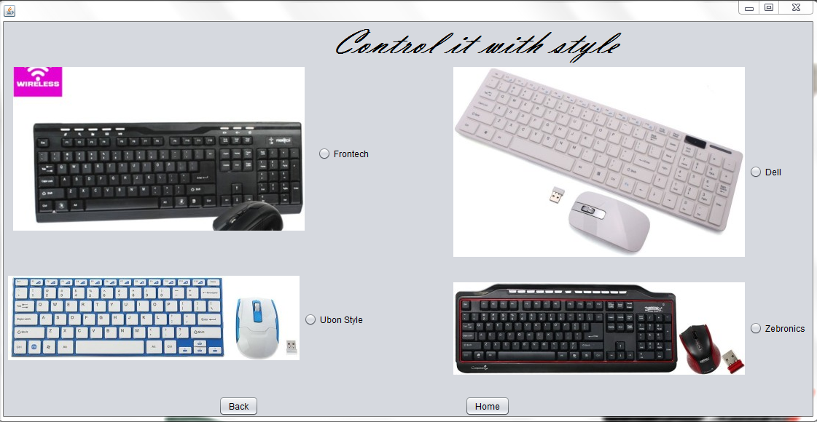

**//import**

import java.sql.*;

public class fifth extends javax.swing.JFrame {

private static final String Username="root";

private static final String Password="";

private static final String connstring="Jdbc:mysql://localhost:3306/connection";

**//back**

new seventh().setVisible(true);

**//frontech**

Connection conn;

try{

conn=DriverManager.getConnection(connstring,Username,Password);

Statement stmt=(Statement)conn.createStatement();

String sql="insert into project values('Frontech',1000);";

int rs=stmt.executeUpdate(sql);

}

catch (SQLException e) {

System.out.print(e);

}

new ninth().setVisible(true);

**//dell**

Connection conn;

try{

conn=DriverManager.getConnection(connstring,Username,Password);

Statement stmt=(Statement)conn.createStatement();

String sql="insert into project values('Dell',1500);";

int rs=stmt.executeUpdate(sql);

}

catch (SQLException e) {

System.out.print(e);

}

new ninth().setVisible(true);

**//ubon style**

Connection conn;

try{

conn=DriverManager.getConnection(connstring,Username,Password);

Statement stmt=(Statement)conn.createStatement();

String sql="insert into project values('Ubon_style',2000);";

int rs=stmt.executeUpdate(sql);

}

catch (SQLException e) {

System.out.print(e);

}

new ninth().setVisible(true);

**//zebronics**

Connection conn;

try{

conn=DriverManager.getConnection(connstring,Username,Password);

Statement stmt=(Statement)conn.createStatement();

String sql="insert into project values('Zebronics',1299);";

int rs=stmt.executeUpdate(sql);

}

catch (SQLException e) {

System.out.print(e);

}

new ninth().setVisible(true);

**//home**

Connection conn;

try{

conn=DriverManager.getConnection(connstring,Username,Password);

Statement stmt=(Statement)conn.createStatement();

String sql="Delete from project;";

int rs=stmt.executeUpdate(sql);

}

catch (SQLException e) {

System.out.print(e);

}

new first().setVisible(true);

new first().setVisible(true);

**Page 9**



**//import**

import java.sql.*;

public class fifth extends javax.swing.JFrame {

private static final String Username="root";

private static final String Password="";

private static final String connstring="Jdbc:mysql://localhost:3306/connection";

**//back**

new Eigth().setVisible(true);

**//enent bigbass**

Connection conn;

try{

conn=DriverManager.getConnection(connstring,Username,Password);

Statement stmt=(Statement)conn.createStatement();

String sql="insert into project values('enent_bigbass',2200);";

int rs=stmt.executeUpdate(sql);

}

catch (SQLException e) {

System.out.print(e);

}

new tenth().setVisible(true);

**//phillips bar**

Connection conn;

try{

conn=DriverManager.getConnection(connstring,Username,Password);

Statement stmt=(Statement)conn.createStatement();

String sql="insert into project values('PhillipsBar',6000);";

int rs=stmt.executeUpdate(sql);

}

catch (SQLException e) {

System.out.print(e);

}

new tenth().setVisible(true);

**//F and D**

Connection conn;

try{

conn=DriverManager.getConnection(connstring,Username,Password);

Statement stmt=(Statement)conn.createStatement();

String sql="insert into project values('FandD',1200);";

int rs=stmt.executeUpdate(sql);

}

catch (SQLException e) {

System.out.print(e);

}

new tenth().setVisible(true);

**//enent bt**

Connection conn;

try{

conn=DriverManager.getConnection(connstring,Username,Password);

Statement stmt=(Statement)conn.createStatement();

String sql="insert into project values('enent_bt',2000);";

int rs=stmt.executeUpdate(sql);

}

catch (SQLException e) {

System.out.print(e);

}

new tenth().setVisible(true);

**//home**

Connection conn;

try{

conn=DriverManager.getConnection(connstring,Username,Password);

Statement stmt=(Statement)conn.createStatement();

String sql="Delete from project;";

int rs=stmt.executeUpdate(sql);

}

catch (SQLException e) {

System.out.print(e);

}

new first().setVisible(true);

new first().setVisible(true);

**Page 10**

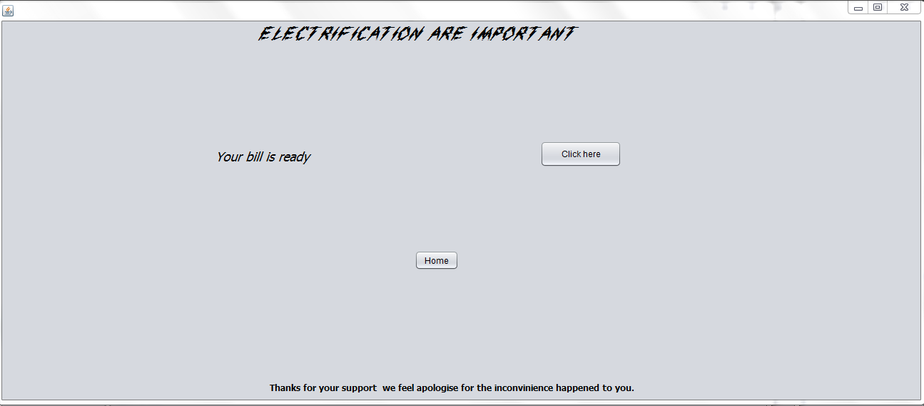

**//import**

import java.sql.*;

public class fifth extends javax.swing.JFrame {

private static final String Username="root";

private static final String Password="";

private static final String connstring="Jdbc:mysql://localhost:3306/connection";

**//click here**

new Eleventh().setVisible(true);

**Page 11**

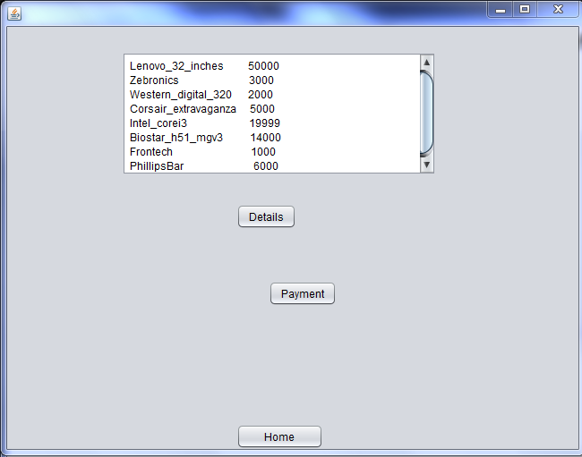

**//import**

import java.sql.*;

public class fifth extends javax.swing.JFrame {

private static final String Username="root";

private static final String Password="";

private static final String connstring="Jdbc:mysql://localhost:3306/connection";

**//details**

Connection conn;

try{

conn=DriverManager.getConnection(connstring,Username,Password);

Statement stmt=(Statement)conn.createStatement();

String sql="select * from project";

ResultSet rs=stmt.executeQuery(sql);

while(rs.next())

{

String name=rs.getString("Product_name");

int c=rs.getInt("cost");

ta.append(""+name+c);

}

}

catch (SQLException e) {

System.out.print(e);

}

**//home**

Connection conn;

try{

conn=DriverManager.getConnection(connstring,Username,Password);

Statement stmt=(Statement)conn.createStatement();

String sql="Delete from project;";

int rs=stmt.executeUpdate(sql);

}

catch (SQLException e) {

System.out.print(e);

}

new first().setVisible(true);

**Page 12**

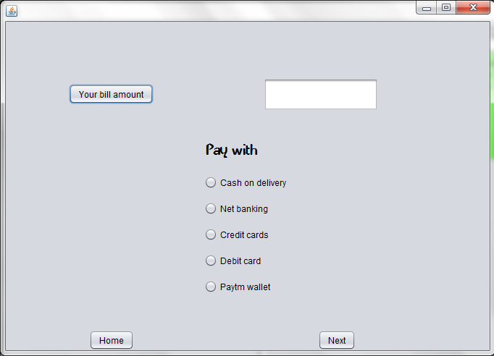

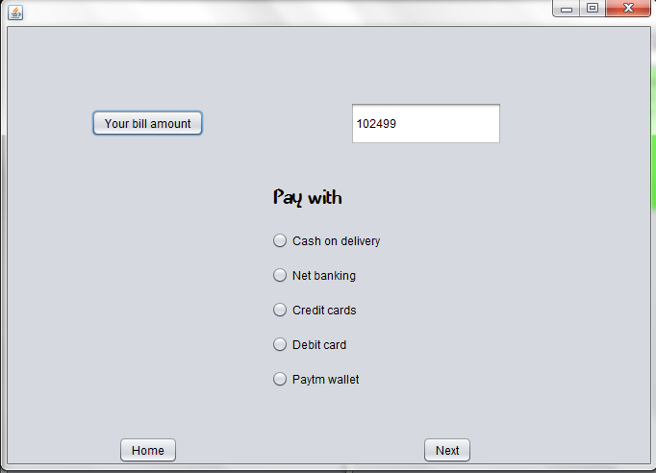

**//import**

import java.sql.*;

public class fifth extends javax.swing.JFrame {

private static final String Username="root";

private static final String Password="";

private static final String connstring="Jdbc:mysql://localhost:3306/connection";

**//back**

new Thirteen().setVisible(true);

**//Your bill amount**

Connection conn;

try{

conn=DriverManager.getConnection(connstring,Username,Password);

Statement stmt=(Statement)conn.createStatement();

String sql="select sum(cost) from project;";

ResultSet rs=stmt.executeQuery(sql);

while(rs.next())

{

int c=rs.getInt("sum(cost)");

tf.setText(""+c);

}

}

catch (SQLException e) {

System.out.print(e);

}

**//home**

Connection conn;

try{

conn=DriverManager.getConnection(connstring,Username,Password);

Statement stmt=(Statement)conn.createStatement();

String sql="Delete from project;";

int rs=stmt.executeUpdate(sql);

}

catch (SQLException e) {

System.out.print(e);

}

new first().setVisible(true);

**Page 13**



**//import**

import java.sql.*;

public class fifth extends javax.swing.JFrame {

private static final String Username="root";

private static final String Password="";

private static final String connstring="Jdbc:mysql://localhost:3306/connection";

**//exit**

Connection conn;

try{

conn=DriverManager.getConnection(connstring,Username,Password);

Statement stmt=(Statement)conn.createStatement();

String sql="Delete from project;";

int rs=stmt.executeUpdate(sql);

}

catch (SQLException e) {

System.out.print(e);

}

System.exit(WIDTH);

}

**//home**

Connection conn;

try{

conn=DriverManager.getConnection(connstring,Username,Password);

Statement stmt=(Statement)conn.createStatement();

String sql="Delete from project;";

int rs=stmt.executeUpdate(sql);

}

catch (SQLException e) {

System.out.print(e);

}

new first().setVisible(true);

**//Cancel your order**

Connection conn;

try{

conn=DriverManager.getConnection(connstring,Username,Password);

Statement stmt=(Statement)conn.createStatement();

String sql="Delete from project;";

int rs=stmt.executeUpdate(sql);

}

catch (SQLException e) {

System.out.print(e);

}

new Forteen().setVisible(true);

**Page 14**

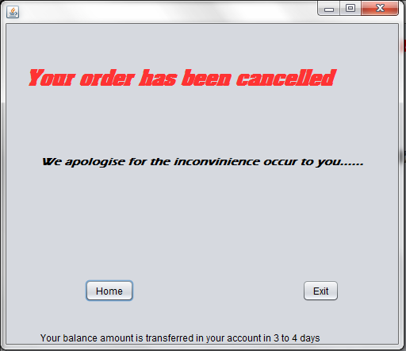

**//import**

import java.sql.*;

public class fifth extends javax.swing.JFrame {

private static final String Username="root";

private static final String Password="";

private static final String connstring="Jdbc:mysql://localhost:3306/connection";

**//home**

Connection conn;

try{

conn=DriverManager.getConnection(connstring,Username,Password);

Statement stmt=(Statement)conn.createStatement();

String sql="Delete from project;";

int rs=stmt.executeUpdate(sql);

}

catch (SQLException e) {

System.out.print(e);

}

new first().setVisible(true);

**//exit**

Connection conn;

try{

conn=DriverManager.getConnection(connstring,Username,Password);

Statement stmt=(Statement)conn.createStatement();

String sql="Delete from project;";

int rs=stmt.executeUpdate(sql);

}

catch (SQLException e) {

System.out.print(e);

}

System.exit(WIDTH);